Single-Phase Seven-Level Grid-Connected Inverter for Photovoltaic System
ABSTRACT
A single-phase seven-level inverter for grid-connected photovoltaic systems, with a novel pulse width-modulated (PWM) control scheme is presented. Three reference signals that are identical to each other with an offset that is equivalent to the amplitude of the triangular carrier signal were used to generate the PWM signals. The inverter is capable of producing seven levels of output-voltage levels from the dc supply voltage. A digital proportional–integral current-control algorithm was implemented to keep the current injected into the grid sinusoidal.
In this paper single-phase seven-level inverter was developed from the five-level inverter. It comprises a single-phase conventional H-bridge inverter, two bidirectional switches, and a capacitor voltage divider formed by $C_{1}, C_{2},$and$C_{3}$. The modified H-bridge topology is significantly advantageous over other topologies, i.e., less power switch, power diodes, and less capacitor for inverters of the same number of levels.
Photovoltaic (PV) arrays were connected to the inverter via a dc–dc boost converter. The power generated by the inverter is to be delivered to the power network, so the utility grid, rather than a load, was used. The dc–dc boost converter was required because the PV arrays had a voltage that was lower than the grid voltage. High dc bus voltages are necessary to ensure that power flows from the PV arrays to the grid. A filtering inductance Lf was used to filter the current injected into the grid. Proper switching of the inverter can produce seven output-voltage levels ($V_{dc}, 2V_{dc}/3, V_{dc}/3, 0,-V_{dc},-2V_{dc}/3,-V_{dc}/3$) from the dc supply voltage.
This paper has presented a novel PWM switching scheme for the proposed multilevel inverter. It utilizes three reference signals and a triangular carrier signal to generate PWM switching signals. The behavior of the proposed multilevel inverter was analyzed in detail. By controlling the modulation index, the desired number of levels of the inverters output voltage can be achieved. The less THD in the seven-level inverter compared with that in the five- and three-level inverters is an attractive solution for grid-connected PV inverters.
The proposed system was verified through MATLAB simulation.
Block diagram for proposed system
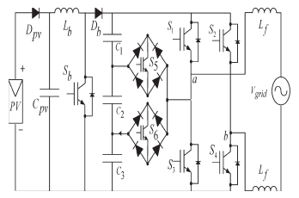
DESIGNG SOFTWARE AND TOOLS:
MATLAB /SIMULATION Software and simpower systems tools are used. Mainly control system tools, power electronics and electrical elements tools are used.

